**How to Assign Employees Specific Jobs in Staffjoy V2**

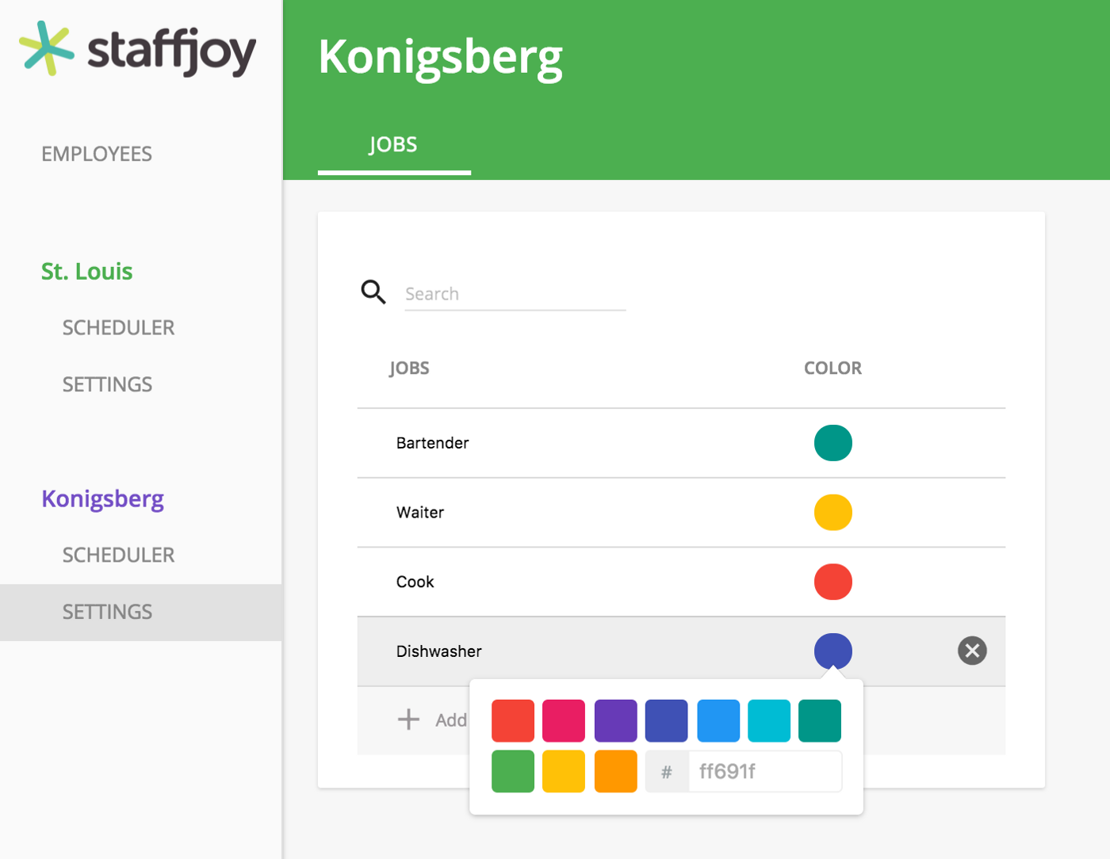

Here at Staffjoy we’re having an action-packed beginning to 2017. [We launched V2](https://blog.staffjoy.com/staffjoy-announces-v2-and-1-2m-seed-round-8abb025a150d#.9cjnjkmn4) of our scheduling software and since then we’ve been able to iterate on it. One thing we’ve heard from many of our V2 early adopters was that it would be useful to have a “jobs” feature. So we listened and we’re excited to announce that Jobs is ready!

**What’s New**

Now that we’ve rolled out our Jobs feature, you can add specific jobs by category. We know that many businesses have employees in different roles, so we want to make sure managers and business owners can schedule employees by job title or function. For example, a restaurant might have a host, waiter, cashier, line cook, and more. On the other hand, say a waiter has agreed to cover a cashier’s shift. You can assign them a cashier shift to make sure you know you have all your bases covered for all hours of operation. With the Jobs feature, you are now able to assign employees shifts based on their role for each shift.

Here’s how you can add a job once you’re logged into Staffjoy V2: **Settings > “Add New Job” under Jobs**

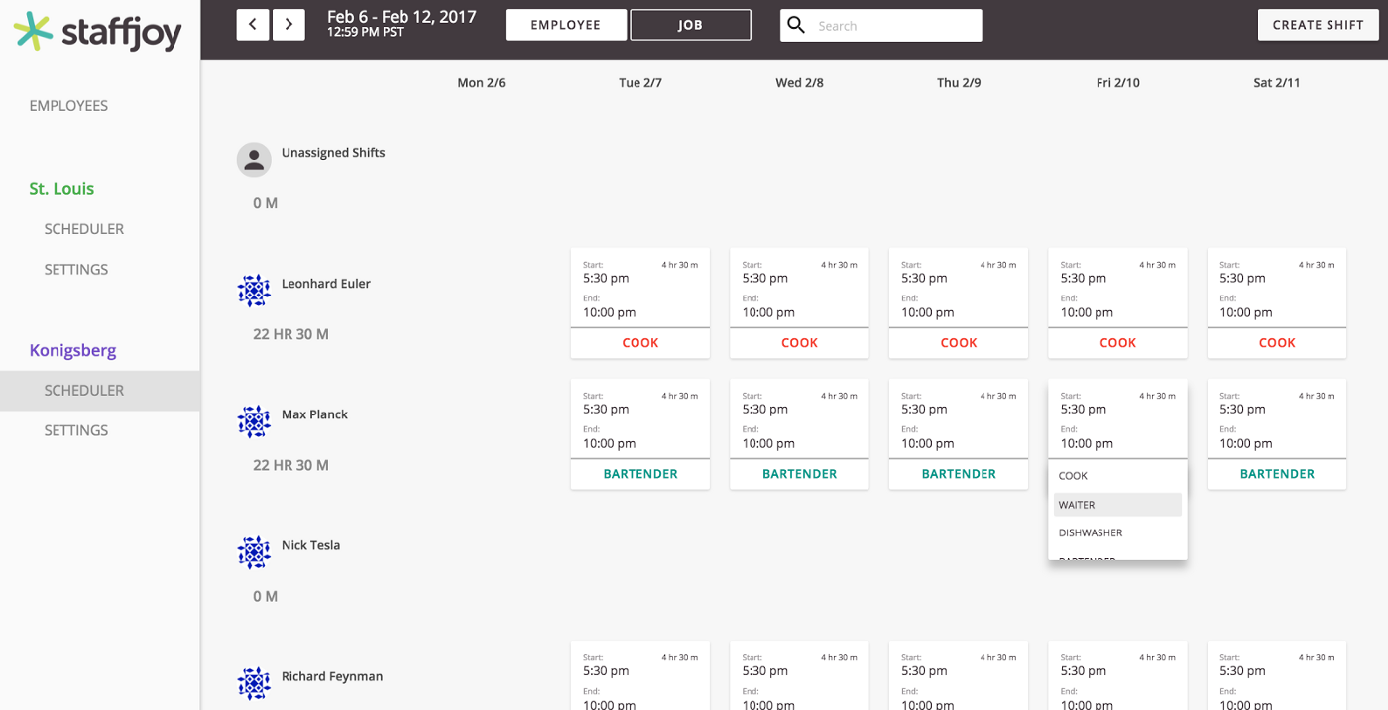

Another example is a customer support provider. In 2017, chat and social media support are required to meet evolving customer needs. That means that support centers need to have employees dedicated to each channel where customers ask questions. Now with a quick click into Settings, you can add and delete job functions as necessary. Also, if you’d like to color coordinate your schedule to further visualize the different jobs your employees will be doing, feel free to assign the color of your choice to each job you add.

**New View of Your Schedule**

In Staffjoy V2 you’re used to seeing the Employee and Job views. When you click on Jobs, now you’re able to create shifts for certain jobs by clicking the “+” next to a role you made. Then you can add in the hours and assign to one or more of your employees. You can even select “Unassigned” if you know you need that role filled at a specific time, but aren’t quite sure yet who will be able to cover it.

The Job view allows employers to see how many hours are being spent on each role each week. Based on the view you prefer, you can toggle back and forth between the Employee view and Jobs view.

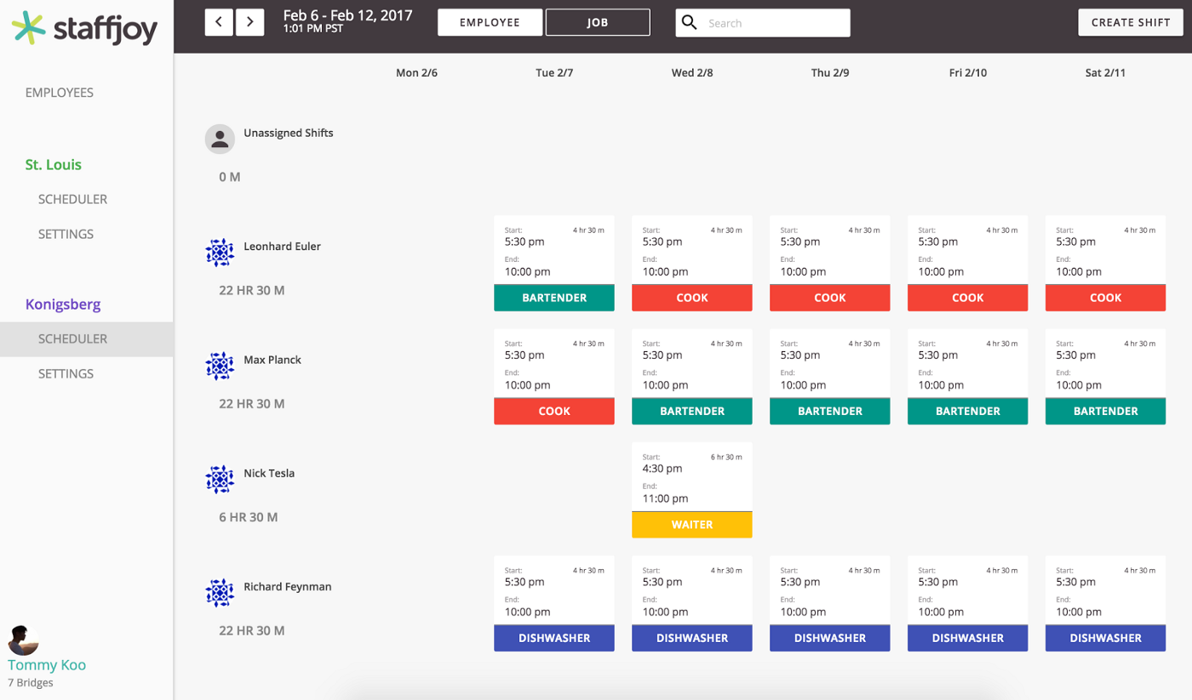

As always, when you change a shift, the employees it affects will receive text messages. The text feature works seamlessly, regardless of the view you use or how you choose to add in shifts. Our system has full-stack support.